**Expert Manual**

**Expert** is a Perturbed Angular Correlation (PAC) Spectroscopy analysis software for calculating Ratio function, *R(t)*. It is developed at University of New South Wales at Australia Defence Force Academy (UNSW@ADFA), Canberra. It is written with Microsoft Visual C#.NET, 2008.

**Requirement:** Microsoft Window XP or higher Window operating systems.

**STEPS FOR USAGE**

1. Type in the parameters for your calculations in the appropriate cells of the P***ropertyGrid***

**Parameters** (see figure 1.) or open a saved parameter file.

1. **Global Parameters**
2. Calibration constant (**CalibConst**) in nanoseconds/channels (ns/chn)
3. Number of channels per spectrum (**Chn_per_Spectrum**)
4. Half life(**Half_life**) of the probe in nanoseconds (ns)
5. Number of channels added(**NoChn4Add**) together for averaging the data
6. Number of spectra (No_**Spectra**)
7. **Spectra Parameters**
8. **Angle** (Angle between the two detectors for a particular spectrum) with options: **Θ1** (i.e. 900 or 109.5) , **Θ2=180** (i.e. 1800) and **NoFit** (for excluding a spectrum)
9. **Invert** (for inverting a spectrum) with options: **Yes** and **No**
10. **TimeZero** (for prompt channel), values in channels
11. Save the parameters for future uses by clicking **Par File** ***splitbutton*** (with options: **Open** and **Save**) on horizontal ***ToolBar*** at the top of the software window then click **Save** option. The name of the parameter file is displayed on the left of the ***StatusBar*** at the bottom of the window. See figure 1.
12. Click **Load *Button*** on the horizontal ***ToolBar*** to load your PAC data. The ***PropertyGrid*** disappears; it is called on/off by clicking **Parameter** ***Button*** on a vertical ***ToolBar*** on the left of the window. The name of the data file is displayed at the middle of the ***StatusBar***. It can open different file formats ( *“ADFA files(*.asc;*.dat)”, ”ANU files(*.asc)”, “Bonn files(*.txt)”, “User-defined files(*.txt)”*). **User-defined file** is a file saved in text format (e.g. notepad) with only count column.
13. Type in the fitting range of the spectrum to be separated in the two ***TextBoxes*** in a ***GroupBox*** on the upper left of the window (see figure 2). Two ***Buttons*** adjacent to these ***TextBoxes*** can be used to get the last cursor position on the canvas for the range by clicking on them.

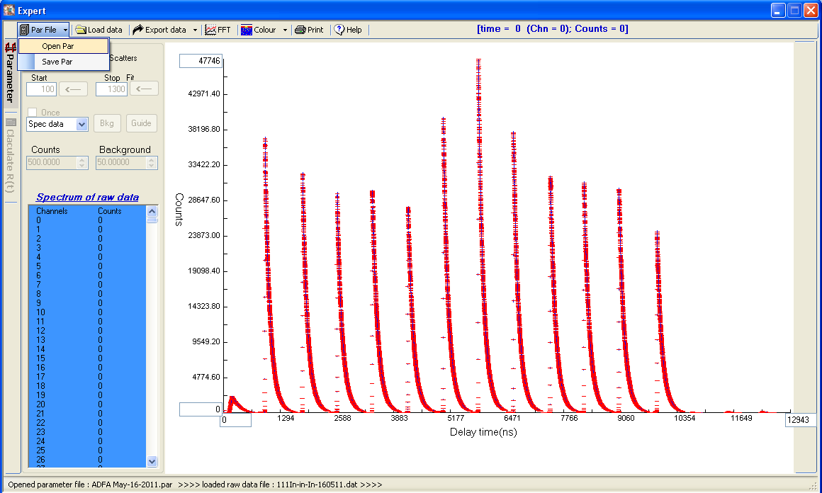

**Figure 1**

1. Select a spectrum by clicking on a ***ComBox*** with a caption **Spec data** in a ***GroupBox*** with caption **Operations.** A drop-list of the spectra and the original spectrum (**Spec data)** is displayed. Clicking on a spectrum displays its plot in red with fit in green, calculated background and count rate in ***NumericUpDown*** controls in the ***GroupBox***.
2. The scale of the spectrum can be toggled between logarithms/linear by checking/unchecking a ***CheckBox*** with a caption **Logarithm** in the upper left of the ***GroupBox.***
3. The spectrum can be plotted between scatters/line by checking/unchecking a ***CheckBox*** with a caption **Scatters** in the upper right of the ***GroupBox***.
4. The background of each spectrum is removed by clicking a ***Button*** with a caption **Bkg** in the ***GroupBox*** one after the other for improved fitting or once by checking a ***CheckBox*** with a caption **Once** for quick fitting. The fit can be improved on by adjusting the calculated **Background** and **Count Rate** by clicking ***NumericUpDown*** appropriately. See figure 2.
5. The Ratio function, *R(t)* is calculated by clicking on a **Calculate R(t)** ***Button*** on the left vertical ***ToolBar***. See figure 3 for an example of R(t) calculated by CanberraFit.

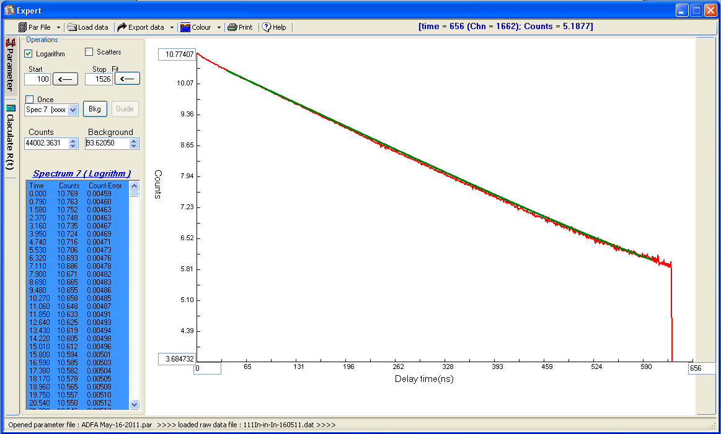

**Figure 2**

1. The R(t) data can be exported into *Nightmare* code (xx.nnr) or text file format by clicking a on a **Export data** ***SplitButton*** on the Horizontal ***ToolBar***. The fit parameters can also be exported into *ShowFit* code parameter file.
2. The data of original spectrum, each separated spectrum or calculated R(t) plotted is shown on ***RichTextBox*** in the ***GroupBox***.
3. The **cursor position** on the plot can be got by clicking on the canvas. It is shown on the right of the horizontal ***ToolBar*** at the top in blue colour.
4. The **plot rescaling(zooming)** is done by:
5. Typing the rescale values in the ***TextBoxes*** on the canvas then press the enter key on the keyboard or
6. Clicking the canvas at the position for the rescaling then right-clicking the canvas and selecting an option from the list that propped up to effect the last cursor position for the rescale.
7. Restoring of the original plot is achieved by pressing the escape key on the keyboard.

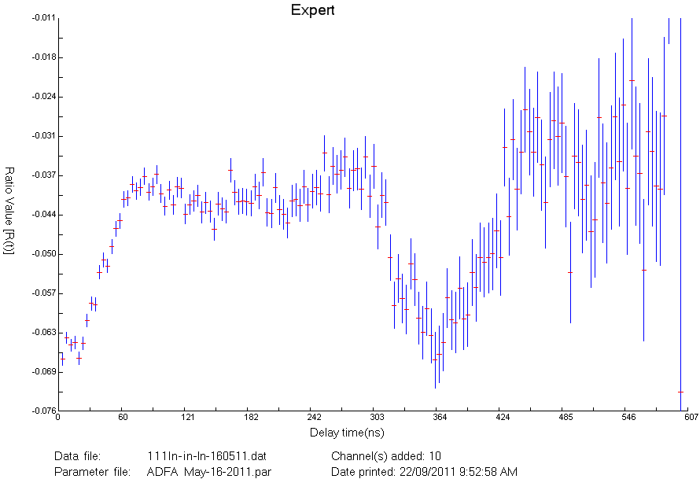

**Figure 3**

1. **Printing of the Spectrum:** the spectrum can be printed by clicking the printing ***Button*** on the ***ToolBar.*** Fig. 3 shows an example. You may have to click the print button on print dialogbox twice.
2. **Color and thickness of line:** The colors and thickness of the data points, the error bars and the fit can be changed by clicking **Color Split*Button*** on the horizontal ***Toolbar*** at the top.
3. For now, the window size of **Expert** is not resizable.